

Tutorial Cover Sheet

Student name: | BANDARU KIRAN SUBRAHAMANYA SAI
Student number: | 3178784
Faculty: | Sheresh Zahoor
Course: | Computing Science |  |  | Stage/year: | 1/1
Subject: | Information Security
Study Mode: | Full time | yes |  | Part-time
Lecturer Name: | Sheresh Zahoor
Assignment Title: | Report
No. of pages: | 7
Disk included? | Yes |  |  | No
Additional Information: | (ie. number of pieces submitted, size of assignment, A2, A3 etc)
Date due: | Friday, 4 April 2025, 9:00 PM
Date submitted: | Friday, 4 April 2025
Plagiarism disclaimer:
I understand that plagiarism is a serious offence and have read and understood the college policy on plagiarism. I also understand that I may receive a mark of zero if I have not identified and properly attributed sources which have been used, referred to, or have in any way influenced the preparation of this assignment, or if I have knowingly allowed others to plagiarize my work in this way.

I hereby certify that this assignment is my own work, based on my personal study and/or research, and that I have acknowledged all material and sources used in its preparation. I also certify that the assignment has not previously been submitted for assessment and that I have not copied in part or whole or otherwise plagiarised the work of anyone else, including other students.
Signed: _B.kiransai ___ Date: _04-04-2025_

Please note: Students MUST retain a hard / soft copy of ALL assignments as well as a receipt issued and signed by a member of Faculty as proof of submission.

Security Attacks
1. Abstract
The subject of communication system security attacks is addressed in this report. It highlights particular and widely known attack types, illustrating how they compromise the confidentiality, integrity, and availability of data. The study presents both theoretical and practical perspectives, including real-world cases such as DDoS and MITM attacks. Readers will understand the types of attacks, how they function, and how to prevent or mitigate their effects. Visuals such as tables and diagrams are included to aid comprehension. The report answers the question: How do different security attacks operate, and what are the most effective countermeasures?
2. Introduction
Security attacks are deliberate and malicious attempts to compromise, disrupt, or exploit the communication infrastructure of organizations and individuals. These attacks can cause significant damage by breaching confidentiality, tampering with data, denying services, or impersonating legitimate users. The growing reliance on digital communication in both public and private sectors has expanded the attack surface, making communication security a top priority.
This report examines the foundational types of security attacks, including passive and active attacks, that impact communication systems. It also presents the structured lifecycle of a cyber-attack and delves into examples that illustrate real-world implications. The aim is to offer a detailed understanding of how these attacks occur and highlight actionable mitigation strategies that can be implemented to build more secure and resilient communication environments.

3. Detailed Discussion
3.1 Types of Security Attacks
Security attacks are mainly categorized into two types:
- Passive Attacks
- Active Attacks
Passive Attacks: The goal of passive attacks is to observe or gather information without altering the system or data. They are difficult to detect and may last long periods.
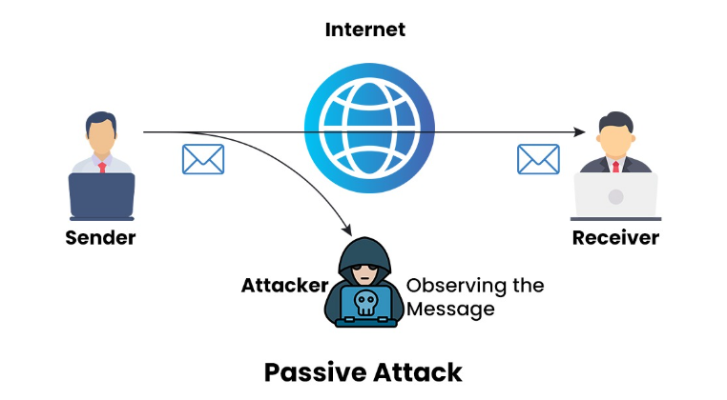
- Eavesdropping: Interception of private communications (emails, VoIP, messages) to extract sensitive data such as passwords or credit card information.
- Traffic Analysis: Even when data is encrypted, analysing traffic patterns (size, frequency) can reveal communication behaviours.
- Passive Reconnaissance: Collecting OSINT (Open-Source Intelligence) to understand a target’s infrastructure before launching an active attack.
Active Attacks: Active attacks interfere with normal communication, modifying or destroying data, or affecting service availability.
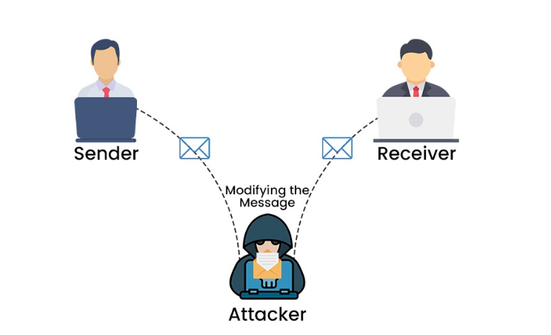
- Man-in-the-Middle (MITM): An attacker secretly intercepts and potentially alters communication between two parties.
- Denial-of-Service (DoS): Overloads a system or network with traffic, making services unavailable. DDoS attacks amplify this by using many compromised devices.
- Spoofing: Impersonation of another user or system to gain access. Common forms include IP spoofing and email spoofing.
- Replay Attacks: Reuse of captured data packets to fool a system into unauthorized operations.
- Masquerade Attack: An unauthorized entity pretends to be a legitimate one to access restricted systems.
- Repudiation Attacks: Attackers deny actions they performed, like transactions or message transmission, creating accountability challenges.
3.2 Attack Lifecycle
The lifecycle of a cyberattack consists of six stages: reconnaissance, installation, exploitation, weaponization and delivery, and command and control. Organizations may increase their total cyber resiliency and reduce the risks of cyberattacks by disrupting the lifecycle with proactive measures, cybersecurity training, and sound security plans.
1. Reconnaissance
As the name suggests, this is the phase in which a possible cyber attacker obtains the data and intelligence required to start organizing an attack. Bad actors frequently gather information from well-known and frequently visited websites, such Facebook, Instagram, and Twitter.
Cybercriminals might also collect emails sent and received by employees or gather intelligence on websites tailored to their target. Research and intelligence gathering on a network, data security, and within pertinent apps or website coding are all included in the reconnaissance phase.
2. Weaponization and Delivery
The next step after completing the reconnaissance phase is to turn that information into a weapon. The weaponization stage's delivery phase can take many forms, but typically consists of malicious attachments, virus-infected websites, or email phishing. Often, all it takes for someone to gain access to the system is for one person to click on a dangerous link or download and install malicious malware.
3. Exploitation
Using the vulnerability is the next step in the cyberattack lifecycle, following the weaponization stage, when the exploit has been implemented in the system, network, or code. Similar to establishing a foothold on a breach and converting it into a staging area, the success of this step represents the adversary's initial admission inside the organization.
4. Installation
Installation occurs after the delivery device and the malicious software complete their tasks of compromising the targeted area, much as the conclusion of the exploitation stage. The main objective of the installation stage is to give the adversaries a secure connection to the network or system so they may launch the assault, not to obtain the needed data.

5. Command and Control
Command and control are closely related but can be separated at times, much like weaponization and delivery. This stage does exactly what its name suggests, despite the fact that it may have military connotations. On both sides of the established link, the opponents are now in control and carry out their offensive strategies. They have successfully taken over the network, system, or application of their targeted victim. The attackers start obtaining sensitive data and private information on their end.
6. Actions
This stage, which may not have the finest title, is when adversaries take action to fulfil their initial intentions. Adversaries can respond to the intrusion they caused in a variety of ways. These are sometimes well-publicized attacks in which a well-known website is altered or vandalized in order to further a cause, humiliate an individual or business, or demand ransom for stolen data. In other cases, weeks or months after the incident, the public just learns about the data leak.
3.3 Communication-Specific Attacks
- Session Hijacking: When an attacker gains control of a user's online activities by stealing or figuring out the information that allows the website to determine that the user is still logged in, this is known as session hijacking.
- Replay Attacks: an attacker obtains information or access without authorization by intercepting and retransmitting a previously recorded data.
- VoIP Eavesdropping: VoIP eavesdropping is a significant security threat where cybercriminals intercept and listen to VoIP calls.

4. Use of Examples, Cases, Diagrams
Example 1: DDoS Attack (Q2 2015)
During Q2 2015, one of the most frequent packet rate attacks was observed. It had a maximum speed of 214 million packets per second (Mpps). Tier 1 routers, such those used by Internet service providers (ISPs), can be removed by that volume.
---Akamai, State of the Internet Q2 2015 Report10
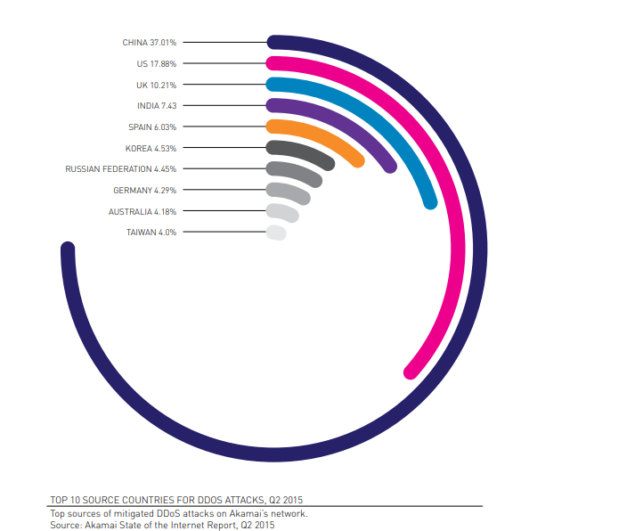
Example 2: MITM Attack (Equifax, 2017)
A well-known example of a man-in-the-middle assault is Equifax, one of the three biggest companies that report credit histories. In 2017, the corporation had a MitM data breach that gave thieves access to the financial information of over 100 million clients over a period of several months.
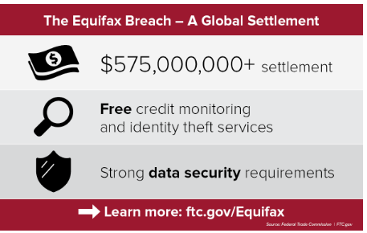

Example 3: Phishing attack (Crelan Bank ,2016)
Crelan Bank in Belgium lost over $75.8 million due to a business email compromise (BEC) scam. In this type of attack, a phisher hacks a top executive's account and instructs their employees to transfer money to an account that is controlled by the attacker. When the Crelan Bank phishing attempt was discovered during an internal audit, the organization was able to sustain the loss because of sufficient internal reserves.
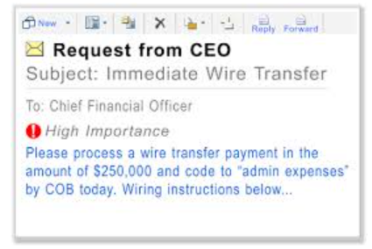
Table: Comparison of Common Attacks
Attack Type | Target | Impact Level | Countermeasure
DDOS | Servers | High | Load balancers,  Firewalls
MITM | Sessions | High | TLS/SSL Encryption
Phishing | Users | Medium | User training, Email filters
SQL Injection | Databases | High | Input Validation, Firewalls

5. Conclusion
Security attacks pose a serious risk to the integrity of communication systems. This report has outlined the most prevalent attacks, their mechanisms, and prevention strategies. By adopting layered defence’s—such as encryption, intrusion detection, and user awareness—organizations can reduce their vulnerability. Awareness and proactive strategies remain the best defence against evolving threats. This report answers the question posed in the abstract by providing a clear view of both the types of attacks and how they are mitigated.

6. References
- https://www.geeksforgeeks.org/active-and-passive-attacks-in-information-security/
- https://www.neumetric.com/journal/differences-between-active-attack-passive-attack/
- https://www.pynetlabs.com/active-attack-and-passive-attack/
- https://www.beyondidentity.com/glossary/man-in-the-middle-attack
- https://www.ftc.gov/news-events/news/press-releases/2019/07/equifax-pay-575-million-part-settlement-ftc-cfpb-states-related-2017-data-breach

